Munich – December 1, 2021

AEC keeps expanding and appoints Alexander Horstmann as new Director Homologation Services
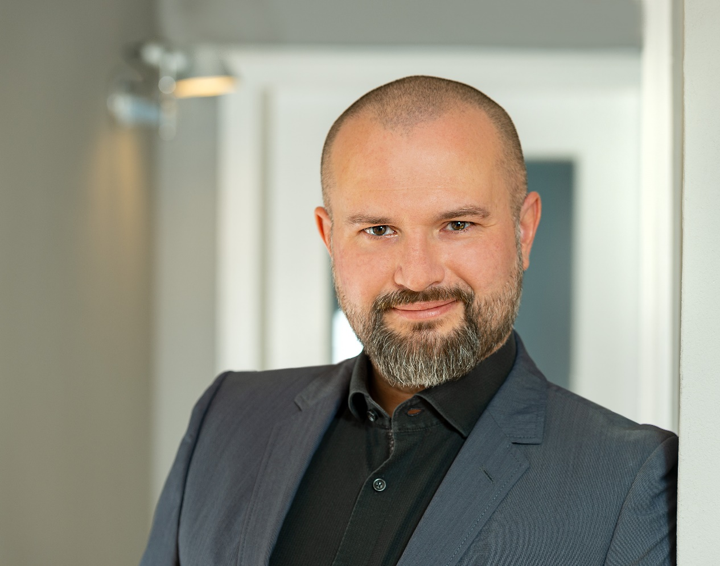
AEC appoints Alexander Horstmann as new Director Homologation Services. As a foundation for future growth, the automotive solutions company expands its Homologation strategy and team. Vehicle compliance and safety expert Alexander Horstman will join from TÜV Süd and will be working closely with technical expert and AEC veteran, Director Engineering, Dany Hoffman and his Research & Development team as part of AEC’s international Homologation Center.

Earlier this year, the global provider of automotive and new mobility solutions and official importer for Dodge & RAM in Europe, has opened a new office in Turin, Italy, and has moved its Belgium team to a new modern and BREEAM certified office in the port of Antwerp. To underline the continuous path of growth of AEC, the Canadian-based company announces that vehicle compliance and safety expert Alexander Horstmann (age 44) will start as Director Homologation Services on December 1.
This newly created role is part of a new strategy, flexibly providing an even broader portfolio of automotive solutions and services. A more in-depth focus on technical adaptation and registration than ever before will result in new opportunities to bring countless new car brands and models to more markets and regions. Close collaboration with administrative traffic offices all over the world facilitates registrations of any scale. This goes hand in hand with the work of AEC’s R&D experts, who have proven expertise and experience to create exclusive technical adaptions, being developed in direct contact with OEM engineers. This way, any alterations to the vehicles can be kept as unobtrusive as possible.

As part of AEC’s international Homologation Center set up, lead engineer, Dany Hoffman (age 48), will keep focusing on Research & Development (R&D) and continue to drive technical innovation and development with a dedicated team of experts, while Alexander Horstmann will put his attention on vehicle regulations and compliance. Other joint topics will be emissions control, and classification, crash safety, pedestrian protection, light conversions, as well as parts and accessory certification to ensure the best possible vehicle experience.

Alexander Horstmann, an FH München engineering graduate, joins AEC from TÜV SÜD, where he has worked as technical supervision and registration expert for over 15 years, leading numerous facilities in southern Germany. In this role, he has already supported AEC’s regulatory work on technical compliance since 2017, focusing on adapting imported vehicles to the specifications of foreign markets. As part of AEC, he will curate future business strategies within the import/export and homologation business and play an integral part in building out AEC’s international Homologation Center.

“25 years ago, we started out to provide unique solutions for bringing vehicles to foreign markets and some of the most remote places on the planet. Over the years, these solutions, as well as our expertise grew along with the company. It generally hasn’t changed to this day, and I am proud to say that we can now take one of our core competencies to the next level by expanding our global AEC Homologation Center and getting ready for the future with new solutions and services. With years of experience in vehicle approval and registration, Alexander is the best expert in his field to support us, and I am delighted to welcome him as part of our AEC team now. He will be an ideal partner for Dany Hoffman and his R&D and Innovation team, and I cannot wait to see even more variety and agility in our homologation processes,” comments Andrew Pilsworth, CEO of AEC.

“We live in exciting and challenging times. Looking at the development of the global automotive market, we currently see opportunities and solutions that didn’t really exist before. I am convinced that AEC will manifest its position as a truly global player in the Homologation space. AEC is an agile and dynamic international company with a great company culture built around people, and always focused on delivering solutions for its various groups of customers. This is the best environment for me to actively participate in the transformation of the industry and helping to design future automotive solutions for more and more international markets,” says Alexander Horstmann, Director Homologation Services at AEC.

For more information about AEC and its Homologation Team, please visit AEC’s company blog.

About AEC

AEC provides a full range of scalable solutions of automotive products and services, including the official distribution of Dodge and RAM brands for Stellantis on the European market, worldwide fleet business, parts, and new mobility.
AEC operates as market entry partner for brands in unknown territory, offering 25 years of experience, 150 international automotive and subject matter experts, seven locations worldwide and the drive to help our partners to succeed in growing their brands in respective markets.
Imbedded in AEC’s expertise are market homologation including own R&D facility and processing center in Antwerp, parts distribution and warehouse, automotive consulting, automotive financing (partner of Santander Consumer Bank in key European markets), fleet operations, logistics solutions as well as retail services
Over 130 European AEC dealers were officially appointed and authorized by the manufacturer. The service portfolio of the importer towards its network includes warranty, recall administration as well as financial services but also certification and training, public relations and marketing support. Customers turn to AEC for its reliable solutions and services, high quality products and strong infrastructure that includes a vast contractual network of retail dealerships and critical partners in the automotive industry.
Founded 1996 in Canada, AEC today has local operations and facilities in its focus markets in NAFTA, APAC and EMEA, and its EMEA headquarter is based in Munich. Find more information on https://www.aecsolutions.com/ or on our blog: https://blog.aecsolutions.com.

Press Contact; Andreas Jüngling; media@aecsolutions.com; +49 162 204 7010

