Kallo / Munich - August 18th, 2021

Automotive Solutions Company and Official Importer AEC keeps growing and moves into new climate neutral office near Antwerp, Belgium
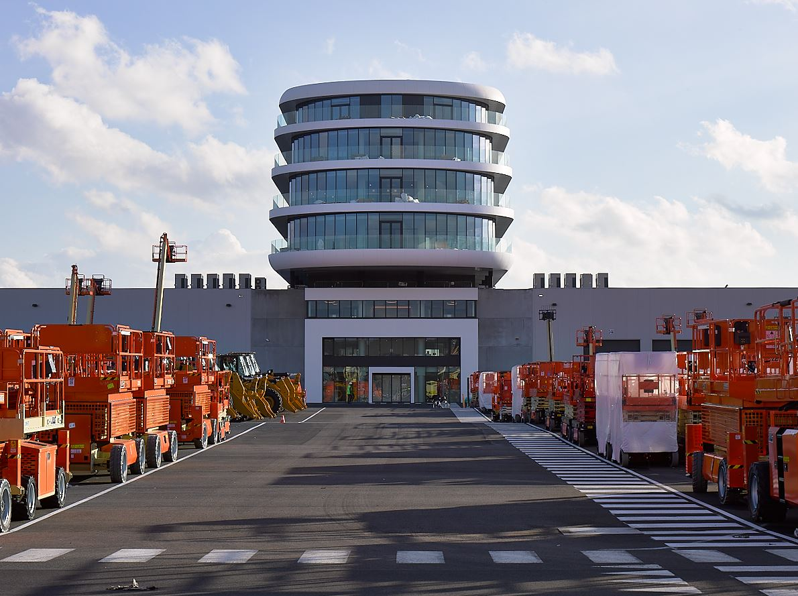

AEC, the automotive solutions provider and official importer of the Stellantis brands Dodge and RAM in Europe, expands its team in Belgium, and will move into a new zero emissions office in Kallo, near Antwerp.

The Canadian rooted company AEC, with branches in Belgium, Italy, China and Sweden and its EMEA headquarter in Munich, Germany, has been continuously expanding, with a year-on-year headcount growth of almost 80%. With many new employees added in all areas of the business and the creation of new divisions and departments, the offices and locales need to be regularly reassessed, with the current focus on Kallo, Belgium, where AEC’s own Vehicle Processing Center (VPC) is also located.

“We are happy to watch our team constantly grow, especially here in Belgium. With a strong growth in employee numbers, and even more colleagues coming on board, we had to adapt to be able to facilitate a great, modern and flexible work experience for everyone, and this is what we have found in our new office around the corner from our VPC,” explains Filip Hamerlinck, AEC’s Manufacturing & Plant Operations Director at the facilities at the port of Kallo. “On the hiring front, we are always looking for highly skilled technicians and talented people from all areas of business.”

AEC has been putting a great focus on the company’s sustainability and made it their goal to find a zero-emission property for their new office in the port of Kallo, district of Antwerp, where the importer receives their cars from overseas and processes the homologation of several thousand units per year in their VPC, which was opened in 2020.

The new 700 sqm office, around the corner from the port, uses Green Energy – a 5 MW windmill on site (in permitting process) will cater to the future growing demand in electrification of all vehicles and machines on site. The building is BREEAM certified, which stands for “Building Research Establishment Environmental Assessment Method” and is the oldest and most widely used certification system for sustainable building. BREEAM's evaluation criteria include: Energy and water consumption, internal environment, pollution, transport, materials, waste, ecology and management. The new AEC office also comes with 34 electric charging stations for cars, a Software management system to monitor energy consumption and storage, a large scale “used” battery for temporary green energy storage 1250 kwh – Zenobe Energy and an emergency backup battery, replacing a diesel emergency generator.

“Finding a sustainable building has been crucial in the process of moving our office into bigger premises. AEC as a company is driven by the goal to actively contribute to positive change, and we have started to drive these changes from within, driving innovation and sustainable choices with our employees, customers and partners. We are ready for e-mobility and are kicking off our first projects in that space. After setting up our Munich office in a LEED Platinum Certified building in 2016, which is the highest possible rating on this sustainability scale, finding a new equal location for our second biggest office in Belgium was an obvious goal. We are looking forward to moving into the new building in September, as one of many steps and changes towards a more resourceful and sustainable future,” COO John Muratori states.

About AEC

AEC provides a full range of scalable solutions of automotive products and services, including the official distribution of Dodge and RAM brands for Stellantis on the European market, worldwide fleet business, parts, and new mobility.

AEC operates as market entry partner for brands in unknown territory, offering 25 years of experience, 130 internationally operating automotive experts, seven locations worldwide and the drive to help our partners to succeed in growing their brands in respective markets.

Imbedded in AEC’s expertise are market homologation including own R&D facility and processing center in Antwerp, parts distribution and warehouse, automotive consulting, automotive financing (partner of Santander Consumer Bank in key European markets), fleet operations, logistics solutions as well as retail services
Over 130 European AEC dealers were officially appointed and authorized by the manufacturer. The service portfolio of the importer towards its network includes warranty, recall administration as well as financial services but also certification and training, public relations and marketing support. Customers turn to AEC for its reliable solutions and services, high quality products and strong infrastructure that includes a vast contractual network of retail dealerships and critical partners in the automotive industry.

Founded 1996 in Canada, AEC today has local operations and facilities in its focus markets in NAFTA, APAC and EMEA, and its EMEA headquarter is based in Munich. Please find more information on https://www.aecsolutions.com/ or on our blog: https://blog.aecsolutions.com, or contact us at: media@aecsolutions.com.

