December 7th, 2020

AEC Europe | Dodge and RAM | Official Importer AEC Europe presents 2021 model line-up for Dodge and RAM vehicles, introducing updates for the entire portfolio

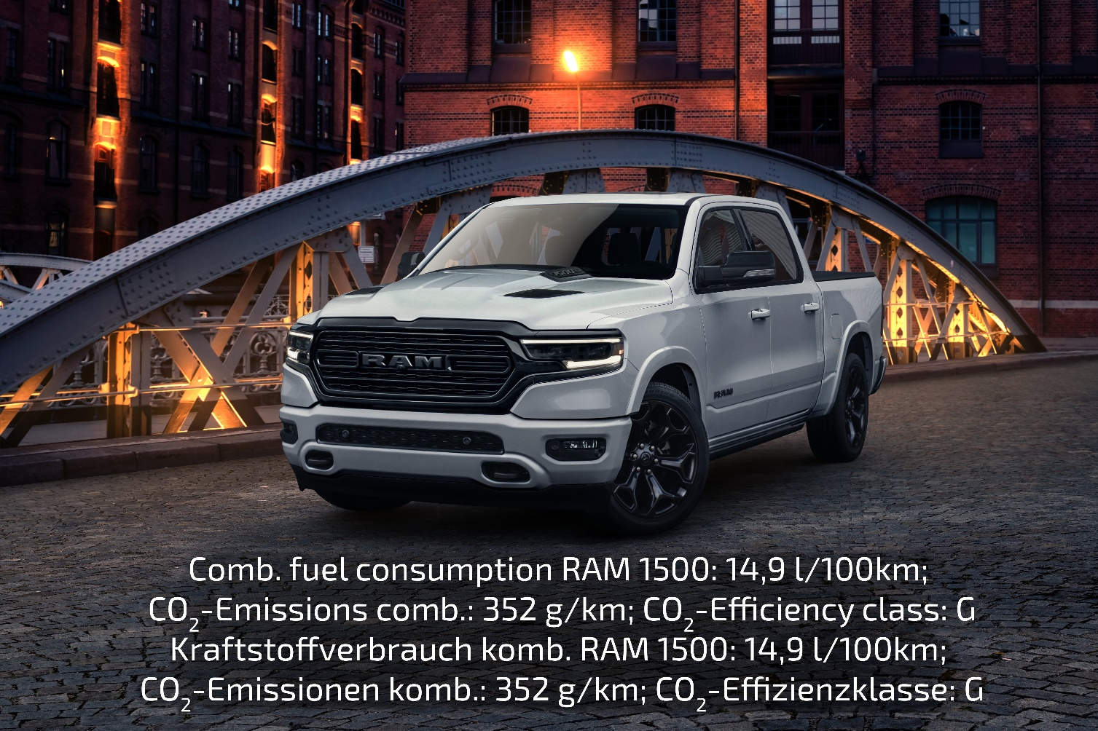

AEC Europe, official Dodge/RAM importer in the EU/EFTA presents 2021 model lineup for Dodge and RAM vehicles, introducing updates within the entire portfolio as well as new models within the Dodge portfolio

- Six instead of five trim levels for RAM 1500
- New features for RAM 1500 and Dodge Durango
- Dodge Charger SRT Hellcat Redeye (808 metric horsepower) most powerful
production sedan in the world
- Dodge Durango SRT Hellcat (717 metric horsepower) most powerful seven-seater in the world

As 2021 is approaching fast, AEC Europe is now offering the newly revised models, bringing even more style, practicality, excitement, and diversity to the RAM and Dodge line-up. The first vehicles have arrived and are being prepared for delivery in AEC’s European Logistics Hub in Antwerp.

With consecutive record-breaking success in sales and customer satisfaction, the 2021 models are tweaked to be even more appealing to a larger variety of drivers.

The RAM 1500 family will be offered in six different trim levels rather than 2020’s five trim level range. Due to the exceptional success of this year’s RAM 1500 Sport, it now ranges under the Laramie moniker while still being the most economical choice. The 2021 trim levels are:

- RAM 1500 Laramie Sport
- RAM 1500 Laramie Night
- RAM 1500 Rebel
- RAM 1500 Longhorn
- RAM 1500 Limited
- New RAM 1500 Limited Night
The Laramie Night and Limited Night models both carry high-gloss black trim pieces all around the truck as well as special black aluminum wheels. They are combined with one of the following colors:

- Ivory White
- Bright White
- Granite Crystal
- Billet Silver
- Diamond Black
But the novelties do not stop on the outside. The interior offers new colors and materials for all trims, as well as some ingenious additions to driver comfort. The engineers focused on the best possible visibility and comfort. With the new heads-up display, all necessary information is projected to virtually hover above the truck’s grill. This way, the driver can always have their eyes on the road. For more visibility towards the rear, RAM trucks now offer digital rear-view mirrors that can show an unobstructed wide-angle camera image of everything behind the vehicle as well as a conventional mirror. Both innovations are part of the standard equipment of the entire RAM 1500 range.

AEC’s new Dodge Models are all about excitement. The 2021 Charger SRT Hellcat Redeye can be identified at first glance by its new and exclusive hood design. There is more big news for this range-topper: With the 2021 Charger SRT Hellcat Redeye, AEC will offer the fastest and most powerful production sedan in the world with a whopping 808 metric horsepower.

With the 2021 models, the entire family can come along and enjoy Hellcat power too. In the new 2021 Dodge Durango SRT Hellcat, a total of seven passengers can experience the heft of 719 metric horsepower, making it the most powerful seven-seater SUV in the world. Admittedly the Hellcat version of the Dodge Durango is tailored to the needs of driving enthusiasts. The entire Durango-Family receives a thorough redesign that brings a fresher look to the exterior and a new, easier to use, and even more luxurious interior crowned by a new semi-digital gauge cluster for improved driver information.

“A new model year can always be seen as an evolution of the previous one. With our great sales success in 2020, we have proven that the AEC RAM and Dodge vehicles are highly sought-after in Europe – now more than ever. In summary, by focusing on the details within the extended range of trim levels, we have tailored our distinctive AEC portfolio even more to the needs of our customers.”
says Mike Tsesmelis, International Sales Director at AEC.

After all this news, the best way to experience the 2021 Dodge and RAM models is still by visiting one of AEC’s over 130 retail partners in all of Europe. Visit aeceurope.com to find all new updates and the one closest to you.

About Auto Export Corporation (AEC)

Auto Export Corporation (AEC) is a global automotive distributor and a service provider for OEMs and suppliers in the areas of general distribution (official FCA importer and distributor of Dodge & RAM vehicles and parts in Europe), market homologation incl. own R&D facility and processing center in Antwerp, parts distribution and warehouse, automotive consulting, automotive finance (partner of Santander Consumer Bank in key European markets), fleet operations, logistics solutions as well as retail services. AEC has local operations and facilities in its focus markets in NAFTA, EMEA, and APAC. Customers turn to AEC for its reliable solutions and existing infrastructure that includes a vast contractual network of retail dealerships and critical partners in the automotive industry.

About AEC Europe – an Auto Export Corporation (AEC) Subsidiary

As an official importer of the Fiat Chrysler (FCA) Dodge & RAM branded vehicles and parts in Europe, AEC Europe is responsible for the distribution and retail network development of the American brands. Over 130 European AEC dealers were officially appointed and authorized by the manufacturer. The service portfolio of the importer towards its network includes market homologation, warranty, parts, recall administration as well as financial services but also certification and training.

