AEC Europe – Press Release, May 12, 2016 – Munich, Germany.

2016 RAM 1500 Laramie Eco Diesel available at AEC Europe

The 2016 RAM 1500 Laramie Eco Diesel is available for Press testing at AEC Europe and for the whole European market.
3,0L Eco Diesel® V6 engine and ZF Torque Flite® 8-speed automatic transmission.
The Laramie Eco Diesel comes with chrome front and rear bumpers, chrome grill and 17-inch chrome-clad aluminium wheels. In the standard equipment also: leather bucket trimmed heated and ventilated front seats, automatic temperature control (ATC), 9 Alpine® speakers with subwoofer.

About AEC
AEC is an authorized importer for the brands DODGE and RAM in Europe, in cooperation with Fiat-Chrysler Automobiles US LLC. Since 2011, AEC has been developing a dealer network that currently includes over 150 dealerships across the continent. AEC supports 300 points of sale and provide a wide range of services, as per instance the full warranty. For further information visit: http://www.aecorp.com/en

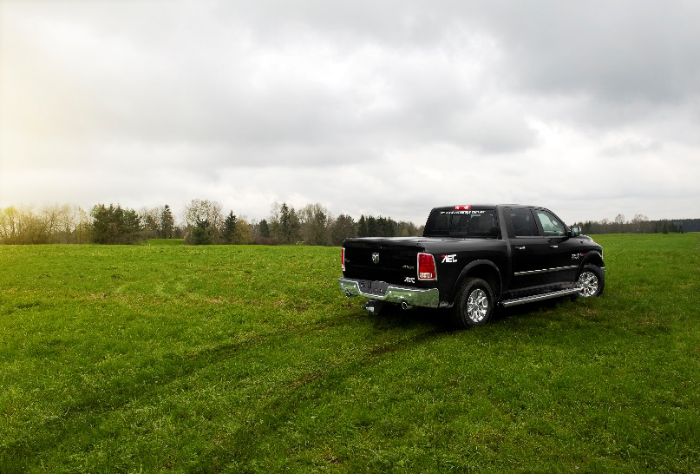
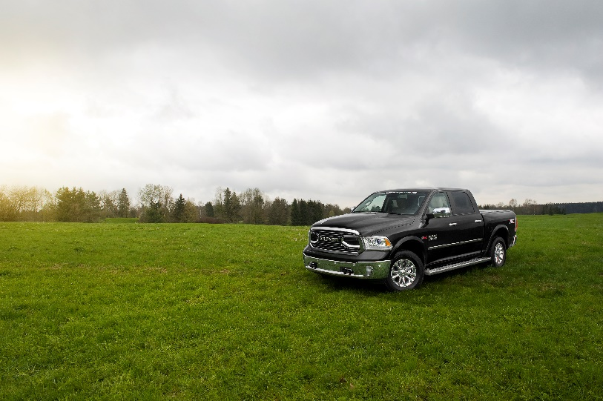
In the picture: 2016 RAM 1500 Laramie Eco Diesel with Limited grill, available for Press testing.

