July 20th, 2020

AEC Europe | Dodge and RAM | Official importer AEC Europe introduces new bull-bar pedestrian safety equipment for RAM 1500

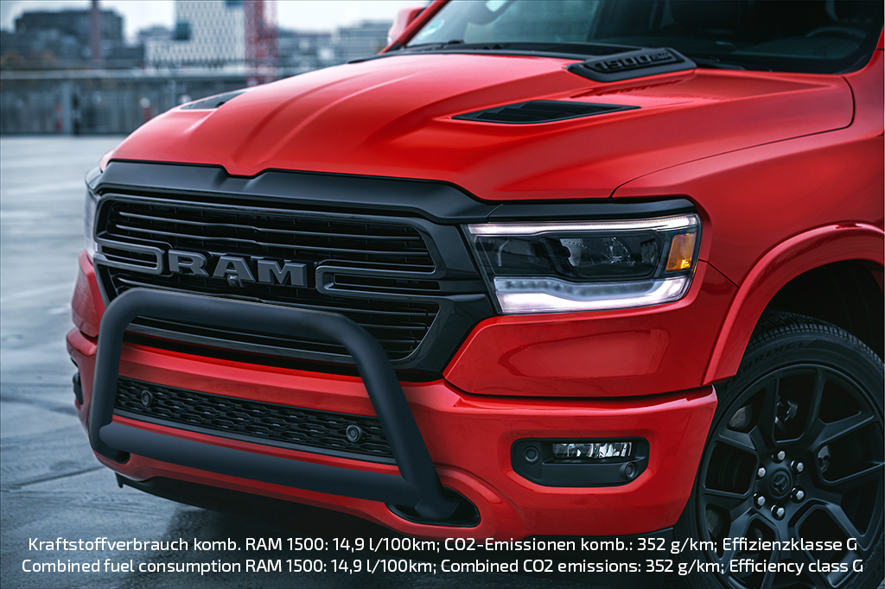

AEC Europe, official Dodge and RAM importer in the EU/EFTA, released a compliance solution for all RAM 1500 DT trucks in accordance with the Austrian pedestrian safety regulation.
AEC’s Engineering Team designed and tested a front bumper extension for RAM 1500 DT (New Generation) trucks that makes the vehicle 100% compliant with the newly enforced EU-regulation 78/2009. AEC is the first official importer to offer an approved solution for RAM in Austria.

The AEC bull-bar is now certified for all RAM 1500 DT models and matches all appearance packages. It comes with official E-Type Approval. After weeks of research and development, as well as thorough testing by AEC in licensed homologation facilities, the system is ready for use in Austria as well as EU-wide as an aftermarket accessory. Its engineering took place during the testing and homologation of the truck’s original bumper and hood structure on all versions and equipment levels for pedestrian safety, which is measurably improved by the bull-bar.

“Instead of engineering a simple quick-fix-solution, AEC’s goal was to create a product that matches our high quality and design standards.”, says Dany Hoffman, Director Homologation and Engineering at AEC. “During the development of products like our bull-bar for the RAM 1500 DT, pedestrian safety is our number one priority, followed directly by high functionality. Nevertheless, it is highly important to give the product the same premium quality finish that our customers expect. It should also match the original design of the truck.”

About Auto Export Corporation (AEC)

Auto Export Corporation (AEC) is a global automotive distributor and a service provider for OEMs and suppliers in the areas of general distribution (official FCA importer and distributor of Dodge & RAM vehicles and parts in Europe), market homologation incl. own R&D facility and processing center in Antwerp, parts distribution and warehouse, automotive consulting, automotive finance (partner of Santander Consumer Bank in key European markets), fleet operations, logistics solutions as well as retail operations. AEC has local operations and facilities in its focus markets in NAFTA, EMEA and APAC. Customers turn to AEC for its reliable solutions and existing infrastructure that includes a vast contractual network of retail dealerships and key partners in the automotive industry.

About AEC Europe – an Auto Export Corporation (AEC) Subsidiary

As an official importer of the Fiat Chrysler (FCA) Dodge & RAM branded vehicles and parts in Europe, AEC Europe is responsible for the distribution and retail network development of the American brands. Over 125 European AEC dealers were officially appointed and authorized by the manufacturer. The service portfolio of the importer towards its network includes market homologation, warranty, parts, recall administration as well as financial services but also certification and training.

