July 1st, 2020

AEC Europe | Dodge and RAM | Official importer AEC Europe on a winning streak with record-breaking sales numbers in first half-year of 2020

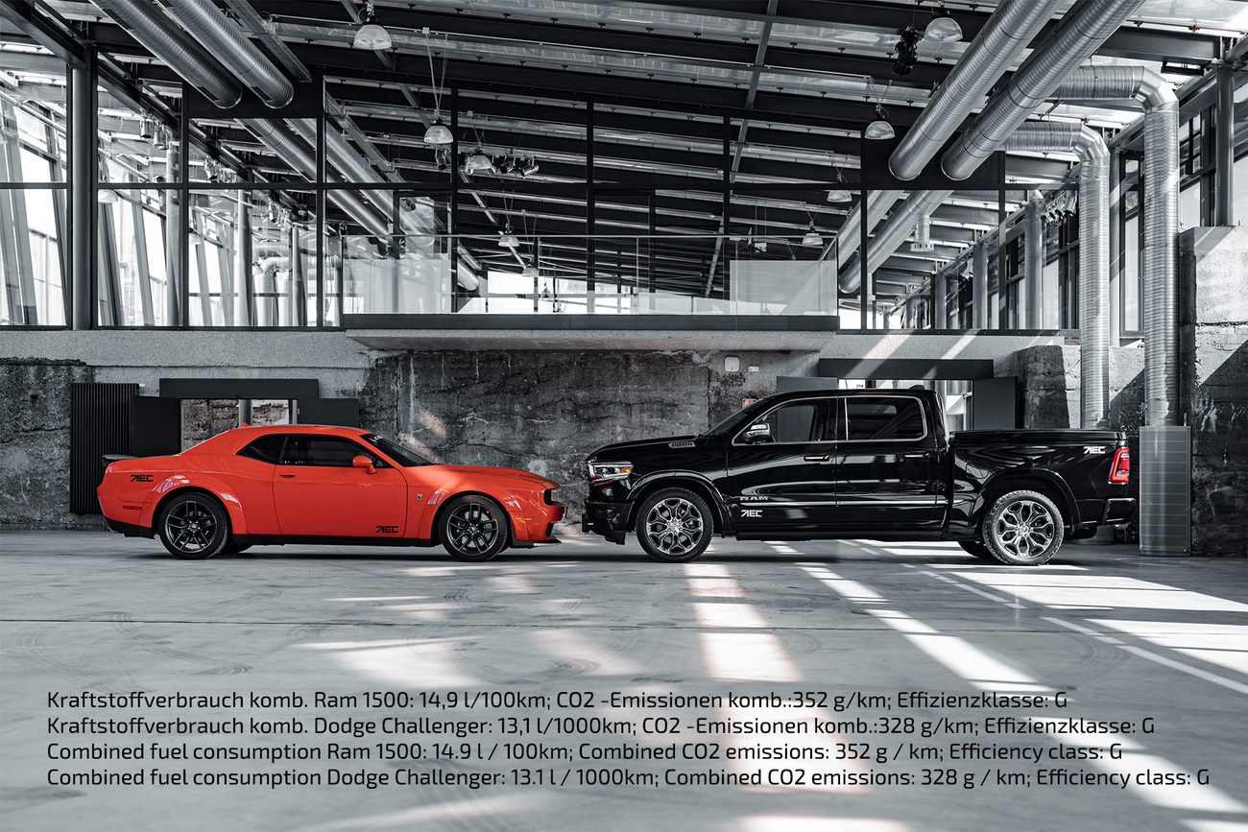

AEC Europe, an official importer of Fiat Chrysler Automobiles’ (FCA) brands Dodge and RAM in the EU/EFTA, closed Q2 of 2020 with several records as European consumers’ appreciation of American muscle cars and pick-ups continues to be on the rise.

The Munich-based official importer announced a slight overachievement of monthly targets in May (+5%) and June (+8%) this year, as well as an all-times-high first quarter (+25% over Q1 2019) and record first half-year results (+10% over the same period in 2019) since the beginning of its official Dodge & RAM program in Europe in 2011.

“We are pleased to see that the mutual efforts of AEC’s Team, our exclusive partners and our outstanding retail network yield these impressive results,” says John R.F. Muratori, Chief Operating Officer of AEC. “We are looking forward to continuing along this successful path during the current year, despite all challenges. In times like these, agility and flexibility are key, and we see a clear trend of OEMs seeking the help of an importer like ourselves that can be faster and ultimately more efficient with niche brands.”

AEC Europe is supplying Dodge & RAM vehicles to its official dealer network of over 125 dealerships all over Europe. The importer attributes the steady growth, among other factors, to the renowned quality of the vehicles, which was most recently recognized by the prestigious J.D. Power U.S. Initial Quality StudySM (IQS), an annual report on new-vehicle quality, where Dodge claimed the 1st and RAM the 3rd spots.

About Auto Export Corporation (AEC)

Auto Export Corporation (AEC) is a global automotive distributor and a service provider for OEMs and suppliers in the areas of general distribution (official FCA importer and distributor of Dodge & RAM vehicles and parts in Europe), market homologation incl. own R&D facility and processing center in Antwerp, parts distribution and warehouse, automotive consulting, automotive finance (partner of Santander Consumer Bank in key European markets), fleet operations, logistics solutions as well as retail services. AEC has local operations and facilities in its focus markets in NAFTA, EMEA, and APAC. Customers turn to AEC for its reliable solutions and existing infrastructure that includes a vast contractual network of retail dealerships and critical partners in the automotive industry.

About AEC Europe – an Auto Export Corporation (AEC) Subsidiary

As an official importer of the Fiat Chrysler (FCA) Dodge & RAM branded vehicles and parts in Europe, AEC Europe is responsible for the distribution and retail network development of the American brands. Over 125 European AEC dealers were officially appointed and authorized by the manufacturer. The service portfolio of the importer towards its network includes market homologation, warranty, parts, recall administration as well as financial services but also certification and training.

