January 22nd, 2021

AEC | Dodge and RAM | AEC expands Parts & Accessories Department due to rising demand.

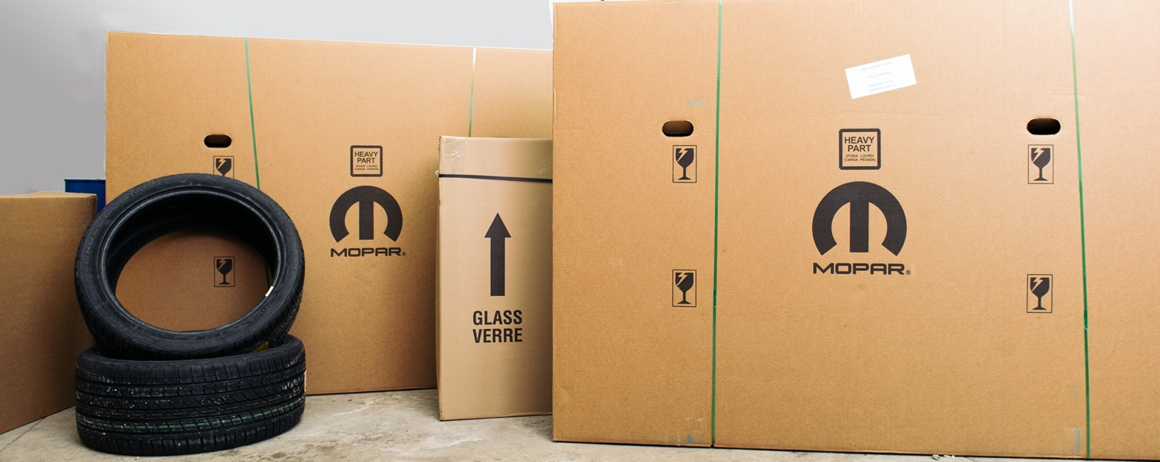

Official Dodge & RAM Importer AEC Europe scales Parts and Accessories Department to the rapidly growing demand by expanding warehouse infrastructure and personnel.

The Munich based official importer of the FCA Brands Dodge and RAM, AEC, announces a significant expansion of their Parts and Accessories Department. After repeatedly accomplishing record-breaking car sales numbers, the demand for parts is expected to grow proportionally. AEC offers access to more than 500.000 different OEM parts and accessories, including fast moving parts, spares, service and maintenance parts. AEC’s own line of accessories and special parts exclusively developed for European customers, as well as a dedicated portfolio of accessories available for installation at their Antwerp Processing Center, are offered as well. Additional to the distributor’s relationship with Mopar, the department relies on a global network of suppliers to specifically cater to the needs of their partners.

To accomplish this expansion, AEC’s Senior Manager Parts and Accessories, Daniele Rossa, significantly raised the headcount of his recently founded department that ensures smooth workflows enabling the team to process dealer and customer requests much more rapidly and efficiently, striving for the best possible service for Dodge and RAM parts in Europe.

“I am very proud of my team’s achievement in the last months. With our colleagues here in Munich and the highly trained experts at our facilities in Antwerp, we are all set for the future demand in parts and accessories. At our new Logistics Hub, we established a whole new concept of warehousing and logistics that enables us to work more cost-effectively while maintaining even more room for expansion.”
says Daniele Rossa, Senior Manager Parts & Accessories at AEC

The warehouse facility moved to larger premises within Antwerp Harbor, offering up to 3000 square meters of storage. Furthermore, AEC optimized processes within supply chain, consolidation, and logistic operations to offer OEM level warehousing standards. Rossa adds:

“One of our main objectives is to keep stock in a very flexible and efficient way that allows us to ramp up the service level for our network and at the same time tailor our inventory to the specific customer requirements. This approach facilitates a short-term delivery system and helps us to keep costs under control.”

The latest AEC Parts & Accessories Catalog can be accessed online by every one of the over 130 licensed retail partners all over Europe.

About Auto Export Corporation (AEC)

Auto Export Corporation (AEC) is a global automotive distributor and a service provider for OEMs and suppliers in the areas of general distribution (official FCA importer and distributor of Dodge & RAM vehicles and parts in Europe), market homologation incl. own R&D facility and processing center in Antwerp, parts distribution and warehouse, automotive consulting, automotive finance (partner of Santander Consumer Bank in key European markets), fleet operations, logistics solutions as well as retail services. AEC has local operations and facilities in its focus markets in NAFTA, EMEA, and APAC. Customers turn to AEC for its reliable solutions and existing infrastructure that includes a vast contractual network of retail dealerships and critical partners in the automotive industry.

About AEC Europe – an Auto Export Corporation (AEC) Subsidiary

As an official importer of the Fiat Chrysler (FCA) Dodge & RAM branded vehicles and parts in Europe, AEC Europe is responsible for the distribution and retail network development of the American brands. Over 130 European AEC dealers were officially appointed and authorized by the manufacturer. The service portfolio of the importer towards its network includes market homologation, warranty, parts, recall administration as well as financial services but also certification and training.

