October 6th, 2020

AEC Europe | Dodge and RAM | Official importer AEC Europe closes 3rd quarter of 2020 with exceptional growth of 78% YoY shattering current sales records

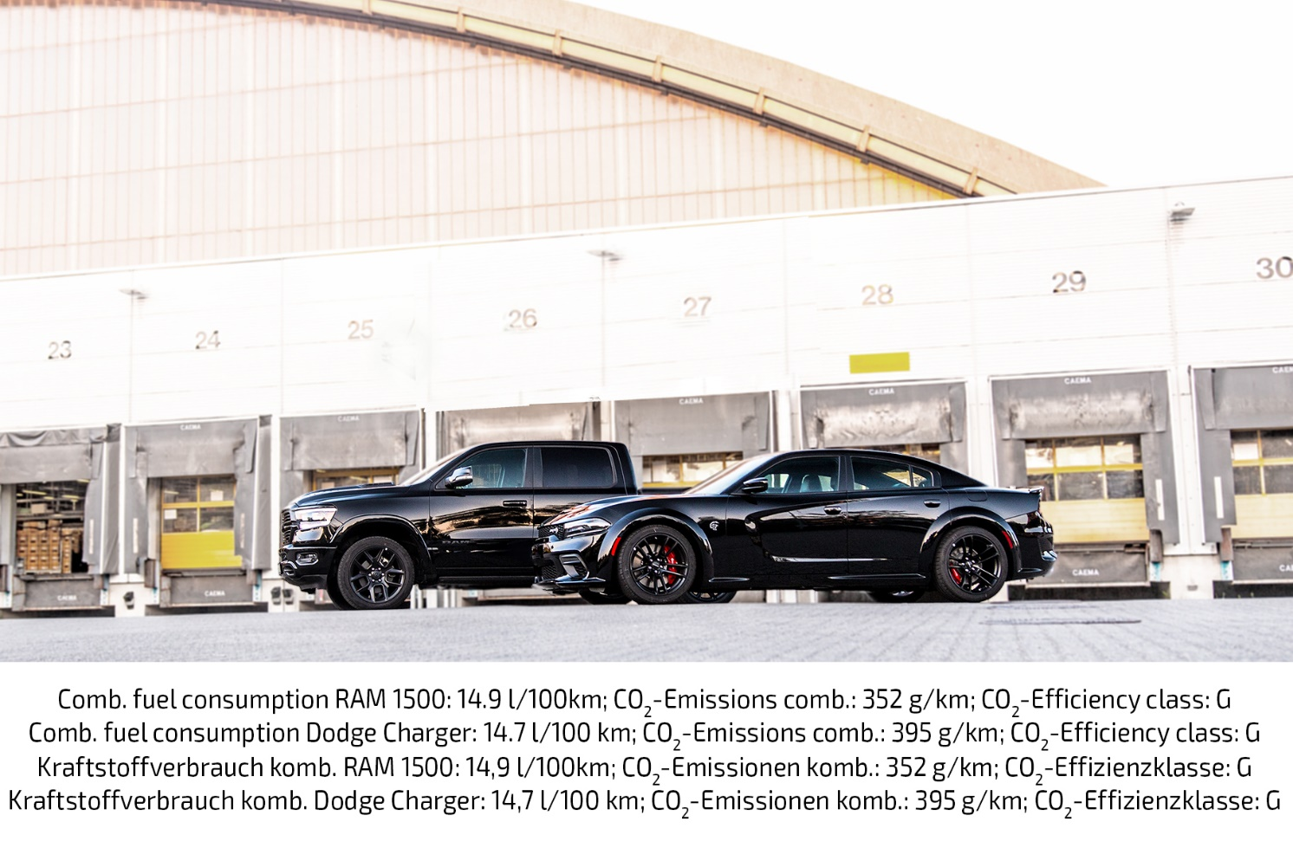

AEC Europe, official Dodge/RAM importer in the EU/EFTA, closes the 3rd quarter of 2020 with exceptional growth of 78% YoY. This shatters the current 2020 sales records and proves continuous interest for American vehicles in Europe.

- Third consecutive quarter with exceptional growth
- 78% in year-over-year increase to 2019’s Q3
- Practically doubled sales numbers in September (YoY)
- Proof for future success of American vehicles in Europe

AEC, the official importer of the FCA brands Dodge and RAM, has been repeatedly reporting new volume milestones this year. Following all-time-high sales volumes in the first half-year of 2020, AEC exceeds its targets once again with record 3rd quarter sales, manifesting its current winning streak by almost doubling the monthly sales compared to the previous year.
When compared to 2019’s Q3, the numbers show a 78% jump in vehicle sales for the same period. On a monthly basis, Q3 2020 has a year-over-year increase of +57,8% in July, +74,7% in August, and a whopping +99% in September – effectively twice the number of vehicles. AEC sees their unique competencies reaching from product planning all the way to their after-sales department as a reason for their success.

“Since we were officially licensed as an importer for Dodge and RAM vehicles by FCA in 2011, we have achieved steady progress every year. By consistently re-investing our gains and – of course – through the great performance of our team, we’re making these jumps bigger each year.”
says Mike Tsesmelis, International Sales Director at AEC.

“These amazing results are not just proof for the current and future success of our company, but also for the continued steady demand for American vehicles in Europe. With this trend, as well as our highly flexible approach to niche markets, AEC can cater to the same needs of other OEMs for future cooperations.”

The Munich-based importer also emphasizes that the highly successful first half-year of 2020 was almost entirely accomplished under the premises of social distancing and work from home due to Coronavirus. Despite the present recession that virtually affects the entire automotive industry, AEC is looking forward to further growth in the near future.

About Auto Export Corporation (AEC)

Auto Export Corporation (AEC) is a global automotive distributor and a service provider for OEMs and suppliers in the areas of general distribution (official FCA importer and distributor of Dodge & RAM vehicles and parts in Europe), market homologation incl. own R&D facility and processing center in Antwerp, parts distribution and warehouse, automotive consulting, automotive finance (partner of Santander Consumer Bank in key European markets), fleet operations, logistics solutions as well as retail services. AEC has local operations and facilities in its focus markets in NAFTA, EMEA, and APAC. Customers turn to AEC for its reliable solutions and existing infrastructure that includes a vast contractual network of retail dealerships and critical partners in the automotive industry.

About AEC Europe – an Auto Export Corporation (AEC) Subsidiary

As an official importer of the Fiat Chrysler (FCA) Dodge & RAM branded vehicles and parts in Europe, AEC Europe is responsible for the distribution and retail network development of the American brands. Over 125 European AEC dealers were officially appointed and authorized by the manufacturer. The service portfolio of the importer towards its network includes market homologation, warranty, parts, recall administration as well as financial services but also certification and training.

