March 8th, 2021

AEC | Dodge and RAM | Official Importer AEC adapts finance solutions in Poland to rising demand

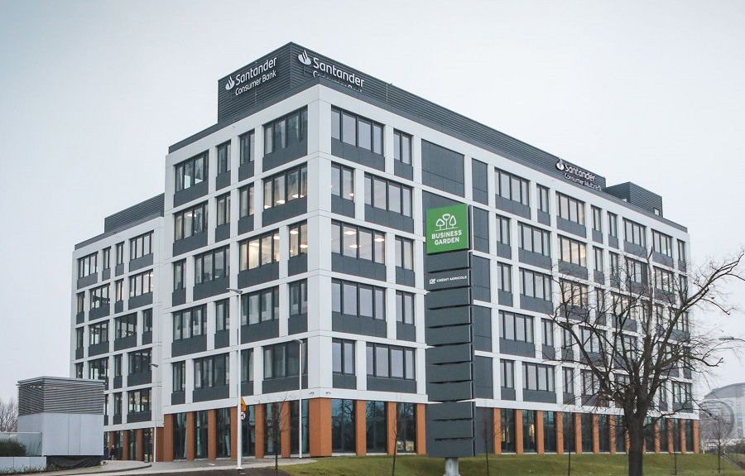

AEC, official importer of the Stellantis brands Dodge and RAM, expands its financial service portfolio with Santander Consumer Bank and Santander Consumer Multirent in Poland

As the sales numbers on the Polish market continue to grow, AEC, official importer of the Stellantis brands Dodge and RAM, now offers financial solutions for retail partners and customers in Poland. In cooperation with Santander Consumer Bank and Santander Consumer Multirent, AEC-Dealers can now offer new AEC vehicles with tailored financing solutions. Furthermore, the partnership with Santander Consumer Multirent facilitates obtaining stock-financed units with a no-interest policy for the first 90 days. This way, even new-founded AEC dealerships can start with an on-site selection of vehicles at no additional cost.

"We know that most of our customers in Poland are private owners, who are demanding individual sales options instead of fixed pricings or commercial offerings. Flexibility is highly appreciated for financing or leasing offers and the selection of vehicles at our dealerships. We sell exciting cars that our customers want to experience. Having expanded our long-term partnership with Santander Consumer Finance to Poland, we now feel that it is a great opportunity for new partners to join our dealership network."
says Maciej Tetelewski, Sales Specialist Eastern European Markets at AEC.
After a very successful closing of 2020, AEC's sales department expects a 50 %-growth in the Polish market alone. Since most of the enormously productive dealerships span over the southern part of the country, the importer is planning to spread out towards the north of Poland.

With Europe's largest automotive financing provider on its side, AEC can look back on five tremendously successful years of partnership with Santander Consumer Finance in a total of six different countries, underlining the company's international business approach.

"Everything grows along with our flourishing sales numbers – our dealer network, the number of markets that we access, and of course, our portfolio of financial services. The fact that our partnership with Santander Consumer Finance grows along with us is the best proof for our accomplishments and a sound future."
Says Robin Bauhofer, Financial Cooperations Specialist at AEC.

AEC's portfolio of Dodge and RAM vehicles is highly sought-after in Poland. The high-performance Dodge models are icons to their enthusiastic drivers. Thanks to AEC's own optional LPG fuel systems, the enormously versatile RAM trucks offer great practicality while being highly economical in their running costs. With over 4000 Autogas stations all over the country, LPG is a widespread type of fuel in Poland.

About Auto Export Corporation (AEC)

Auto Export Corporation (AEC) is a global automotive distributor and a service provider for OEMs and suppliers in the areas of general distribution (official Stellantis importer and distributor of Dodge & RAM vehicles and parts in Europe), market homologation incl. own R&D facility and processing center in Antwerp, parts distribution and warehouse, automotive consulting, automotive finance (partner of Santander Consumer Bank in key European markets), fleet operations, logistics solutions as well as retail services. AEC has local operations and facilities in its focus markets in NAFTA, EMEA, and APAC. Customers turn to AEC for its reliable solutions and existing infrastructure that includes a vast contractual network of retail dealerships and critical partners in the automotive industry.

About AEC Europe – an Auto Export Corporation (AEC) Subsidiary

As an official importer of Stellantis Dodge & RAM branded vehicles and parts in Europe, AEC Europe is responsible for the distribution and retail network development of the American brands. Over 130 European AEC dealers were officially appointed and authorized by the manufacturer. The service portfolio of the importer towards its network includes market homologation, warranty, parts, recall administration as well as financial services but also certification and training.

