March 1st, 2021

AEC | Dodge and RAM | Official Importer AEC launches new 2021 RAM 1500 TRX for European market

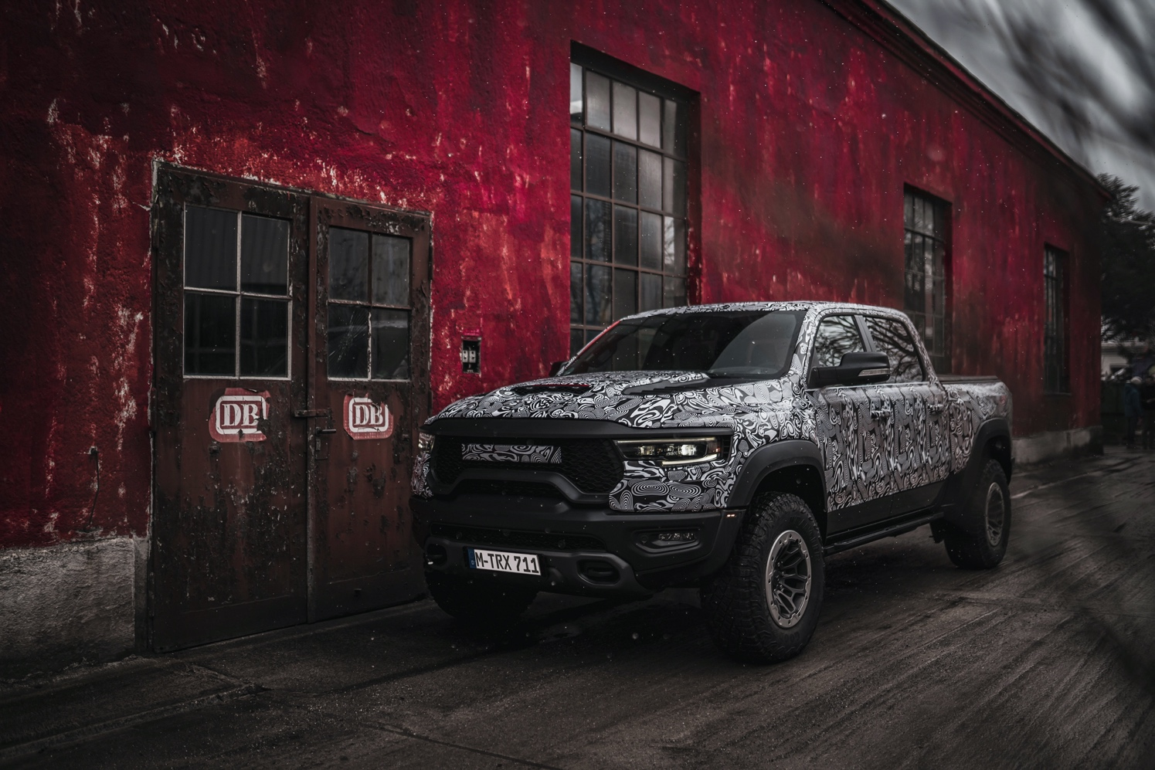

AEC, official importer of the Stellantis brands Dodge and RAM in Europe, launches new flagship RAM 1500 TRX in Europe, accepting customer pre-orders immediately.

The wait is finally over. After AEC’s August announcement of the plans to bring the 2021 RAM 1500 TRX to Europe, the importer now reports that the most powerful production pick-up truck in the world has arrived. The first homologation and testing operations are already in progress and will be concluded soon. AEC starts unleashing the full-size truck with Hellcat performance by inviting a selection of journalists to gather their first driving impressions on the roads of Bavaria in the first week of March.

Additionally, official importer is now booking interest for the 2021 RAM 1500 TRX. With prices ranging from around EUR 100.000 to EUR 115.000 (in addition, local VAT and local taxes will apply), the customers can experience the menacing howl of the TRX’s 6,2 Liter supercharged Hellcat powerplant themselves soon. Specific retail prices will be announced in the second quarter of this year. A power output of 711 horsepower and 881 Newtonmeters of torque makes the TRX the most powerful production pick-up truck in the world.

Apart from the truck’s unrivaled performance, the TRX sports an exclusive suspension with Bilstein Blackhawk shocks that are fully adjustable to the eight drive modes, such as “Street,” “Sport,” or “Baja”. With these features as factory equipment, the new 2021 RAM 1500 TRX is ready to conquer Europe – on and off-road.

“We have had a lot of success with our powerful V8 performance models and with the growing success of our pickup trucks over the years; this daring combination is a match made in heaven for the many fans in Europe. Therefore, we wanted to reduce lead time to market for the new 2021 RAM 1500 TRX and have worked hand in hand with Stellantis to make this happen. I am very pleased that our first unit is already registered and has completed most European test runs.”
Says Sasha Saita, Brand & Product Marcom Director at AEC.

With the launch of the 2021 RAM 1500 TRX, AEC now offers the famous Hellcat engine in three different models, including the Dodge Charger SRT Hellcat and the Dodge Challenger SRT Hellcat.

Of course, the new TRX owners will enjoy the full 360-degree customer experience that AEC offers for any vehicle in their line-up. This includes finance options, a two-year warranty, all AEC after-sales services, as well as MOPAR parts supply and a plethora of individual accessories.

Discover more at www.aecramtrucks.com/trx.

About Auto Export Corporation (AEC)

Auto Export Corporation (AEC) is a global automotive distributor and a service provider for OEMs and suppliers in the areas of general distribution (official Stellantis importer and distributor of Dodge & RAM vehicles and parts in Europe), market homologation incl. own R&D facility and processing center in Antwerp, parts distribution and warehouse, automotive consulting, automotive finance (partner of Santander Consumer Bank in key European markets), fleet operations, logistics solutions as well as retail services. AEC has local operations and facilities in its focus markets in NAFTA, EMEA, and APAC. Customers turn to AEC for its reliable solutions and existing infrastructure that includes a vast contractual network of retail dealerships and critical partners in the automotive industry.

About AEC Europe – an Auto Export Corporation (AEC) Subsidiary

As an official importer of the Stellantis Dodge & RAM branded vehicles and parts in Europe, AEC Europe is responsible for the distribution and retail network development of the American brands. Over 130 European AEC dealers were officially appointed and authorized by the manufacturer. The service portfolio of the importer towards its network includes market homologation, warranty, parts, recall administration as well as financial services but also certification and training.

