February 8th, 2021

AEC | Dodge and RAM | Official Importer AEC expands Vehicle Processing Center in Antwerp with new facilities, adapting to growing volumes

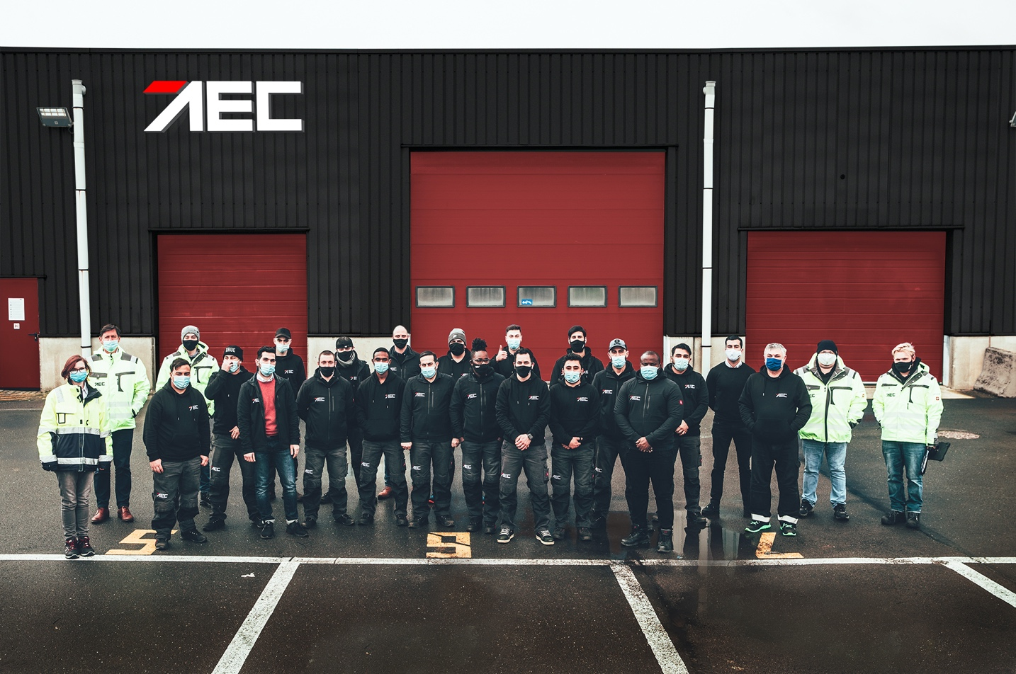

The global automotive solutions provider and official importer of the Fiat Chrysler Automobiles (FCA) brands Dodge and RAM, AEC, expands production facilities and storage lots in the port of Antwerp, practically doubling its capabilities.

With sales numbers of Dodge and RAM vehicles on a constant incline, the global automotive solutions provider AEC has launched a new facility in Antwerp harbor. The additional Vehicle Processing Center (VPC 2) allows almost twice as many vehicles to be prepared for delivery. The conversions applied at AEC’s processing centers reach from the technical adaptation of lights, navigation systems, or tow hooks to applying underbody coating to OEM standards. The company uses one of Europe’s largest coating installations outside of manufacturing plants to prepare the vehicles for the rigors of winter, salt, or road debris. All of this is part of AEC’s technical services, ultimately supervised by quality control teams.

Furthermore, the vehicle processing centers are used to install AEC’s exclusive equipment options. Thanks to optimized supply chains, thousands of parts and customizing items are delivered instantly from the company’s nearby warehouses. An essential piece of equipment is AEC’s exclusive Autogas system for RAM vehicles. It is installed by dedicated teams within the VPC 2 compound.

“Expanding port facilities comes with two major aspects: New people and more workspace. Our new employees enjoy specific training by our experienced technicians, resulting in a steep learning curve. I’m proud that even the newest members of my team put in great effort to achieve our targets throughout the high demand of the last weeks. We are first in line to experience AEC’s tremendous growth. Thanks to our flexible approach, we grow along too. Around our new VPC 2 building, we have about 130 hectares of space that allows us to store up to 1200 cars flexibly at any given time. Space is no issue. Of course, this also facilitates moving the vehicles within the terminal.”
says Christophe Plaieser, Port Operation Manager at AEC.

All efforts are taken to provide more vehicles to AEC’s vast dealer-network with shorter lead times and as a testament to the high demand for American cars in Europe. Optimizing the technical services ultimately improves the customer experience thanks to continuously reduced waiting times.

About Auto Export Corporation (AEC)

Auto Export Corporation (AEC) is a global automotive distributor and a service provider for OEMs and suppliers in the areas of general distribution (official FCA importer and distributor of Dodge & RAM vehicles and parts in Europe), market homologation incl. own R&D facility and processing center in Antwerp, parts distribution and warehouse, automotive consulting, automotive finance (partner of Santander Consumer Bank in key European markets), fleet operations, logistics solutions as well as retail services. AEC has local operations and facilities in its focus markets in NAFTA, EMEA, and APAC. Customers turn to AEC for its reliable solutions and existing infrastructure that includes a vast contractual network of retail dealerships and critical partners in the automotive industry.

About AEC Europe – an Auto Export Corporation (AEC) Subsidiary

As an official importer of the Fiat Chrysler (FCA) Dodge & RAM branded vehicles and parts in Europe, AEC Europe is responsible for the distribution and retail network development of the American brands. Over 130 European AEC dealers were officially appointed and authorized by the manufacturer. The service portfolio of the importer towards its network includes market homologation, warranty, parts, recall administration as well as financial services but also certification and training.

