November 19th, 2020

AEC Europe | Dodge and RAM | Official importer AEC Europe celebrates five years of strong partnership with Santander

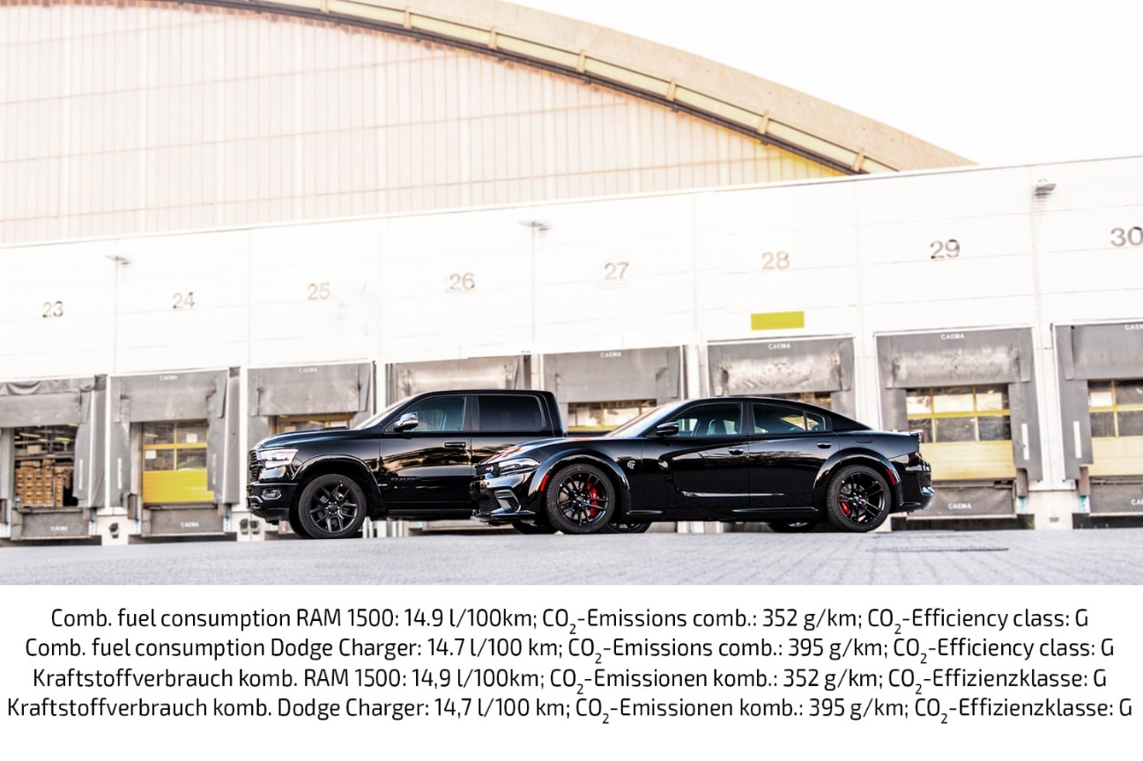

AEC Europe, official Dodge and RAM importer in the EU/EFTA celebrates five years of strong partnership with Santander Consumer Finance (SCF) in retail- and wholesale-financing
Mönchengladbach, November 19th 2020. It was exactly five years ago, on November 19th, 2015, when AEC started their financial service cooperation with Santander Germany. In these five years, both partners grew closer together, creating a win-win situation for both companies.
Santander’s expertise in financial services and AEC’s know-how as a globally active automotive solutions provider and official importer of the FCA brands Dodge and RAM vehicles and parts are an unrivaled match.

Tackling every task with close teamwork and face-to-face communication is the cooperation’s key to success. The steady growth in sales numbers is an ideal index for the continuous demand for niche-market vehicles. Many customers are wishing for an alternative to regular European vehicles. For them, many markets can only provide an insufficient choice.
Enthusiasts of legendary U.S. cars can now opt for various leasing contracts in addition to the financing solutions that are already provided. The cooperation reacts to market requirements and rising demand by customers in a joint effort.

“The collaboration with AEC is a great foundation for Santander to fortify our position as the market leader in the sector of finance solutions – also for special vehicles such as the typically American RAM 1500. We can offer a combination of attractive financing- and leasing-products and tailor-made support in sustainable growth to the dealerships. We are very happy about our great collaboration with AEC in the years past and we are sure of its future success.”
says Daniele Moranelli, Director Collaboration Agreements at Santander.

“Our cooperation with Santander is the perfect proof for our strategic orientation. Just like that, we can offer finance solutions for our entire portfolio from a single source. Thanks to our collaboration, this benefit can be fully passed on to our retail partners, who can in turn give financing- and leasing-offers to end-customers much quicker. With Dodge, RAM, and the entire future portfolio of AEC, we are looking forward very much to years of successful partnership with Santander.”
says Natalie Gitter, Director Corporate Communications and Strategic Cooperations at AEC.

Media inquiries:

Miriam Makrewitz
Communications Specialist (AEC)
+49 173 385 45 89
m.makrewitz@aeceurope.com

Marcel Gerblich
Project Manager Marketing B2B
+49 2161 690 70 69
marcel.gerblich@santander.de

About Auto Export Corporation (AEC)

Auto Export Corporation (AEC) is a global automotive distributor and a service provider for OEMs and suppliers in the areas of general distribution (official FCA importer and distributor of Dodge & RAM vehicles and parts in Europe), market homologation incl. own R&D facility and processing center in Antwerp, parts distribution and warehouse, automotive consulting, automotive finance (partner of Santander Consumer Bank in key European markets), fleet operations, logistics solutions as well as retail operations. AEC has local operations and facilities in its focus markets in NAFTA, EMEA and APAC. Customers turn to AEC for its reliable solutions and existing infrastructure that includes a vast contractual network of retail dealerships and key partners in the automotive industry.

About AEC Europe – an Auto Export Corporation (AEC) Subsidiary

As an official importer of the Fiat Chrysler (FCA) Dodge & RAM branded vehicles and parts in Europe, AEC Europe is responsible for the distribution and retail network development of the American brands. Over 130 European AEC dealers were officially appointed and authorized by the manufacturer. The service portfolio of the importer towards its network includes market homologation, warranty, parts, recall administration as well as financial services but also certification and training.

Santander Consumer Finance (SCF)

Santander Consumer Finance (SCF) is a leading consumer finance company present in 15 European countries, China, and Canada. More than 14,500 professionals provide leading consumer finance products and services to more than 19 million customers and 130,000 point of sale partners at the close of June 2020. SCF offers a wide range of consumer finance solutions, mainly through point-of-sales, where the company has developed a unique expertise, and direct-to-consumer channels such as branches, phone centers and internet. SCF is part of Santander, one of the largest financial groups in the world.

Banco Santander (SAN SM, STD US, BNC LN)

Banco Santander (SAN SM, STD US, BNC LN) is a leading retail and commercial bank, founded in 1857 and headquartered in Spain. It has a meaningful presence in 10 core markets in Europe and the Americas and is one of the largest banks in the world by market capitalization. Its purpose is to help people and businesses prosper in a simple, personal, and fair way. Santander is building a more responsible bank and has made a number of commitments to support this objective, including raising over €120 billion in green financing between 2019 and 2025, as well as financially empowering more than 10 million people over the same period. At the end of the first half of 2020, Banco Santander had more than a trillion euros in total funds, 146 million customers, of which 21.5 million are loyal and 40 million are digital, 11,800 branches and 194,000 employees

